Picture Music
Eric Anderson
UCSC CMPS161 Winter 2014
3/19/2014

ABSTRACT
Most of the visualizations of data today are developed in eye-catching illustrative simulations. This is largely in fact due to computers’ abilities to process visual data quickly. Not much work has been put into the visualization of data through sound.
This project is meant to develop a coherent stream of music from picture-data of sufficiently high resolution through several different analysis of the picture data. As with many picture formats, raw picture data only consists of color (RGB) data, and their pixel coordinates. From this, several things can be derived. Such things include, but are not limited to gradient, statistical means and modes, and number of distinct colors. Much of this data is already used for photo and image editing programs such as Photoshop.

Visualizing “seen” data as “heard” data is something that has yet to be perfected for humans to adopt. Although sound may be a data-medium we use further into the future, it has yet to be explored.

INTRODUCTION
By inputting pictures and photos through this program, a pattern of notes is created, laid out, and played back through mapping certain color data schemes. Some of the data derived from the color-data in the picture is explained below.

Gradient, or the change in color over a pixel-cell, is calculated through utilizing the Sobel-gradient method, which is a simple weighting through using square distances.

$$G(Δx,Δy)=\sqrt{({ Δx}^{2}+ Δy^{2})}$$

Critical Points, or the points in which the gradient is 0 and there is no change along the x or y axis in an image, is calculated by using a simple filter (since RGB color is a scalar value).

$$CP=\sum_{k=0}^{n}{\left\{\left(k_{x}, k_{y}\right)\right\} ∈ } G\left(Δx,Δy\right)≠0$$

Color Mapping, or the general color that a specific RGB falls into (category wise) is mapped to RGB buckets. Instead of using buckets (hash-keys) for each individual color, RGB is broken up into 16x16x16 (maximum of 4096) buckets. This allows the program to specify 4096 unique “generic” colors to sort.

$V\left(Δx,Δy\right)=$floor($V\left(Δx,Δy\right).r)$
Main Section
The data used for the program is pictured below. The results must be listened to, so you will need to utilize the program in order to get a feel for the results.
The mapping is as follows – the light intensity (brightness) corresponds to whether or not the piece of music is major or minor. The variance of color in the image determines its tempo. The gradient (from top left, right then down), is mapped to the “bumblebee” scale that plays.

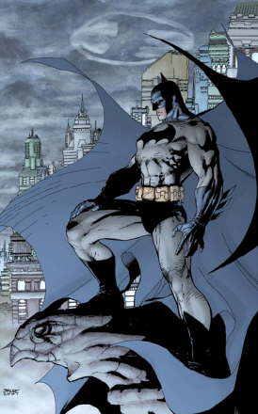
Image 1

This picture of batman is intended to present a mild tempo with a wide scale range in what might seem to be a minor scale (due to the immense amount of black). The average color temperature of this picture, however, is actually light, so the theme is in major.

Image 2

This droplet of blood is intended to have a major color of red. However, what ends up happening is that the white background turns out to be a secondary color, which creates severe gradients and balances out the music. The music is played in major, albeit there is an average tempo and a coarse gradient.
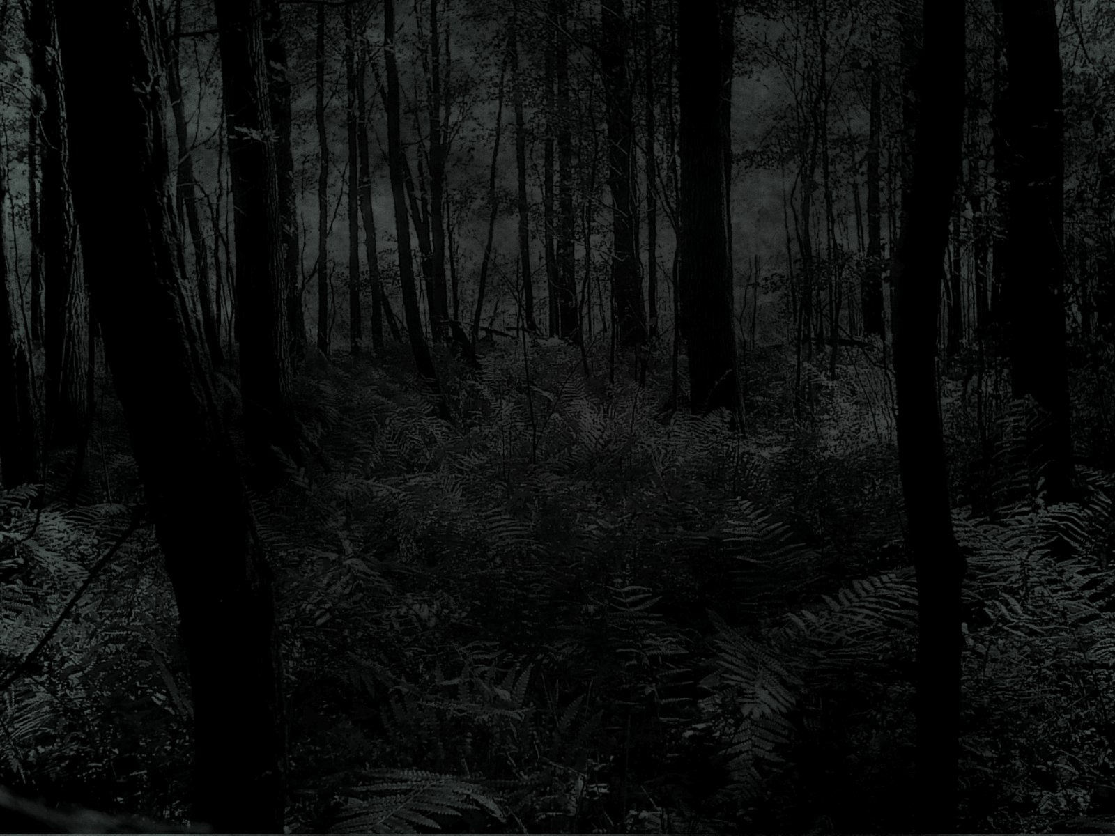Image 3

This particular image is one of the outliers out of all the images in the data set. The extremities are seen here, as the tempo is slow due to the invariance of color. The theme is obviously in minor, and the music “creeps” along as would be represented by the image.
Image 4
Image 4 is very similar to Image 3, except the tempo is at an average pace. The theme is still minor, and the color adds a little bit of variance on the “bumblebee” scale.

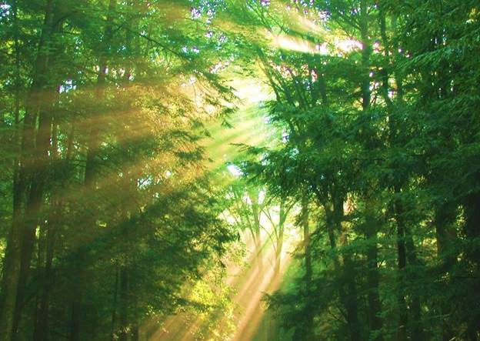
Image 5

The variance of color in this image (from white, to yellow, and green) allows for the scale to have variety. The tempo is moderate, and the theme is in major as the average color temperature of the image is extremely vibrant.

Image 6

Image 6 presents an in-door common color of reddish brown, which is a common color for indoor environments (as it is the color of many objects, as well as wood). This awfully cute kitten actually adds to the color of the background, which doesn’t offer much color variance to the rest of the image.

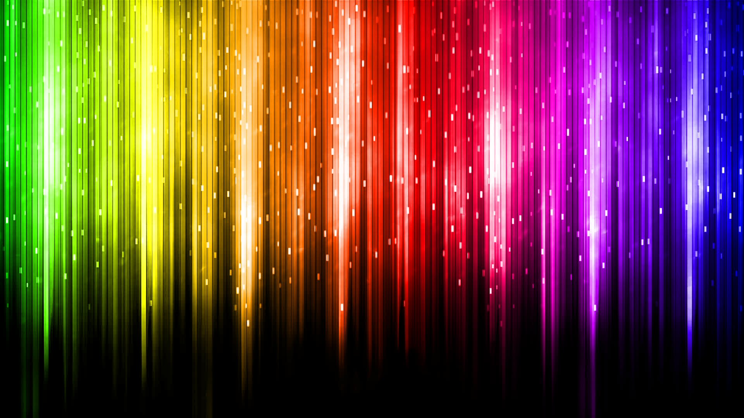
Image 7

This image is another outlier, as well as one of the unexpected results. The primary color is actually black, despite the variety of colors in this image. The scale here appears in sound just as chromatic as it would appear in the image. The theme is minor despite its appearance.

Image 8

This image is one of the only bright images in the set, being played in major with a mild rhythm. The variance of color is mild, with light blue, blue, and white being the primary colors here.

RESULTS
Several problems were wrought out with dynamic music visualization in this project. Many things, like tune-generation, were scrapped. Many tunes cannot be dynamically generated yet still make sense to human beings. Some similar projects (like the Music Generator on Wolfram Alpha) also attempt to dynamically create tunes, most of which are seeded to a point that they do not make any more musical sense than the path of a bumblebee.
Music theory is easily able to represent minor and major chords, scales, and arpeggios well. Reasons for this may be because that music theory defines what notes go well with others in specific formations, where tunes are random patterns that humans tend to recognize and attune to.
CONCLUSION
In retrospect, the project was much more difficult in designing than intended. Originally, I was planning to get several layers and tracks sufficient to occupy all the spots of a band. However, even a disconcerted disjoint band (dynamically playing music) unsynchronized does not sound harmonious, and is likely less easy to understand from a user’s point of view.

Hopefully this project will open up data visualization to multiple perspectives, as graphics (and the human eye) has its limitation.

REFERENCES
Image 1-8 Google Images
Wolfram-Alpha Tones http://tones.wolfram.com/generate/

